Roshan Mykoo

MIU

3/3/2015

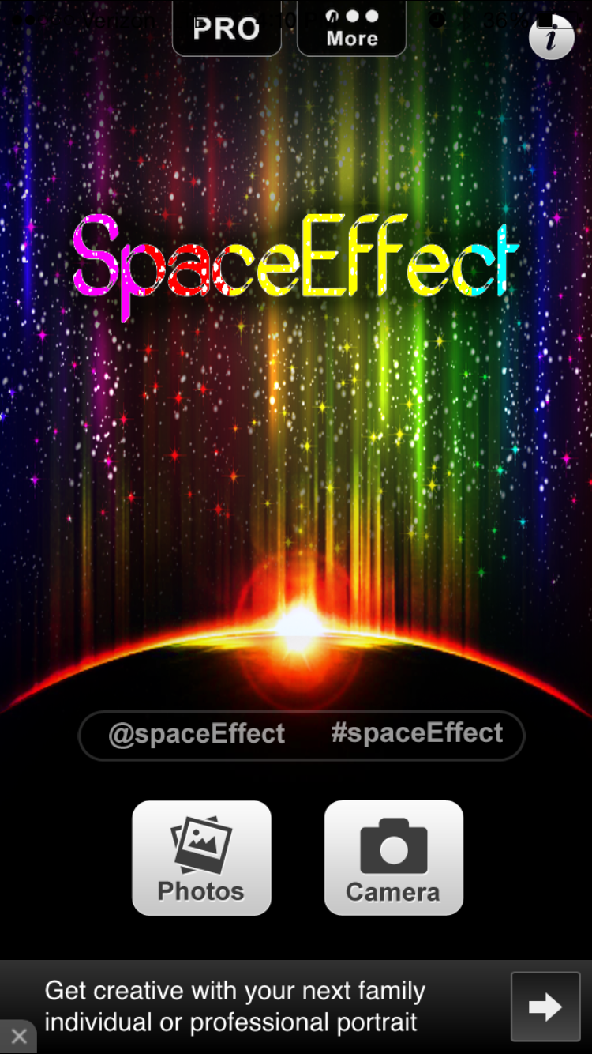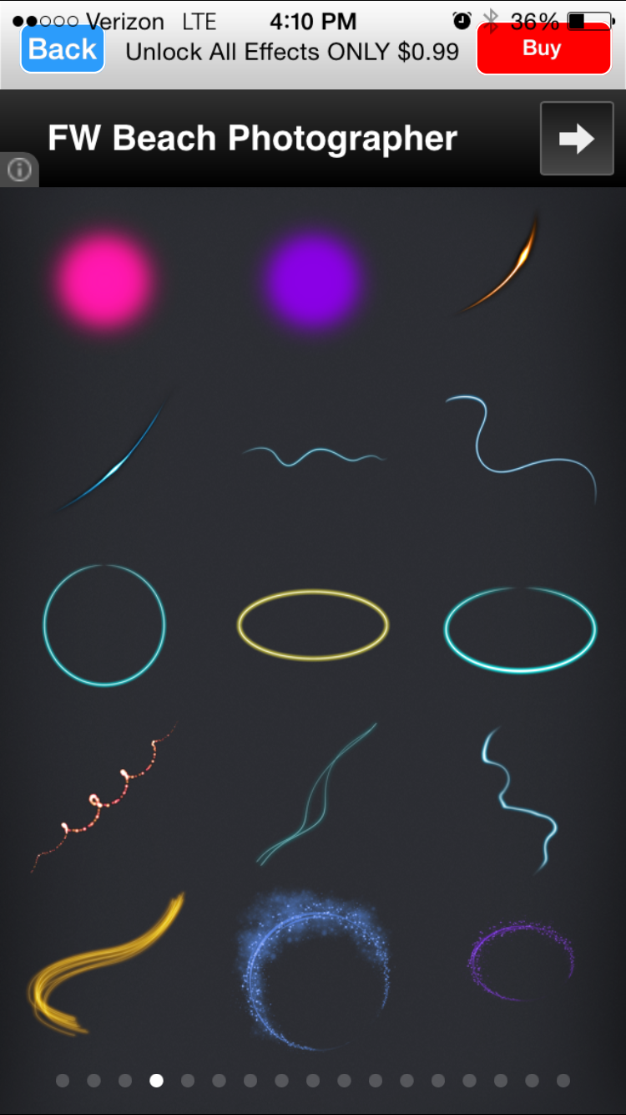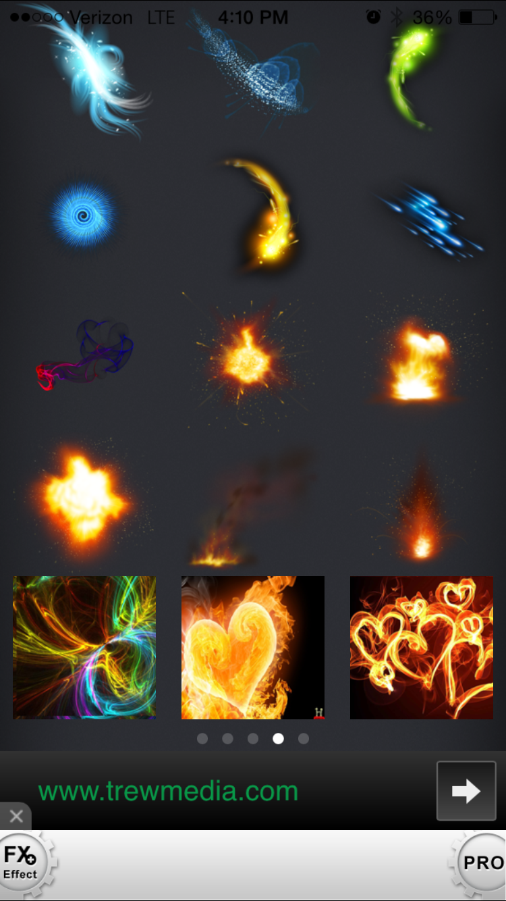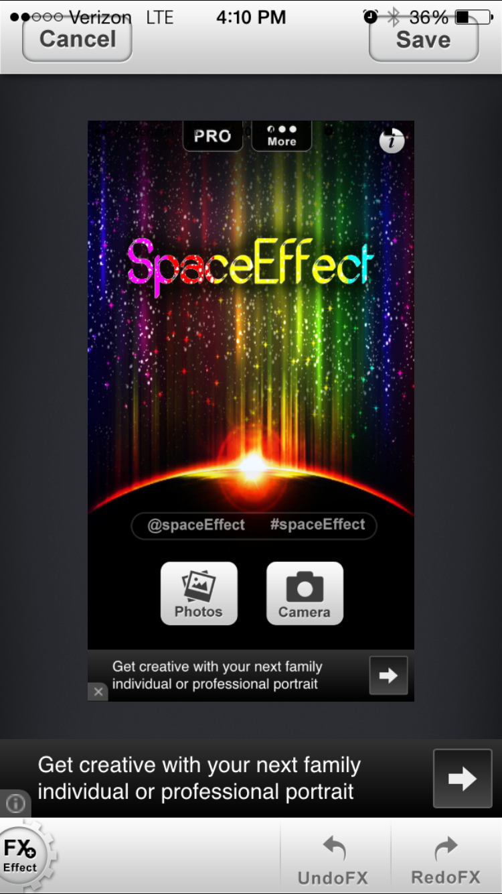

In the SpaceEffectFX PRO App, it allows you to edit photos on your device by adding different pre set render effects to an image. The effect itself can be positioned anywhere on the picture and can be configured to change its rotation or its opacity. After the photo is edited you have the ability of saving the edit directly to your device or to post to social media.

If I were to make changes to improve this app first I would reposition my headers and navigation bars to properly fit each specific platform it is running on. This app was originally made for the iPhone 4, but it does not cross over to well to the iPhone 6. Also I would then organize the effects into folders of which displays examples of the certain effects that can be found inside. And last, I would reposition the add Views so that they do not interfere with the user’s interaction with the photo editing.